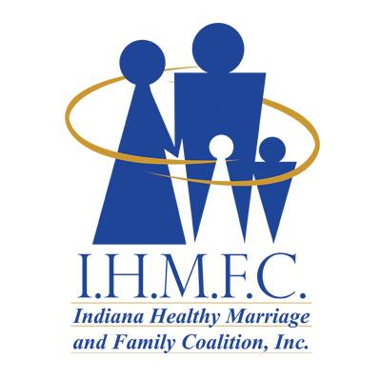
Greetings!

We proudly announce that the Indiana Healthy Marriage and Family Coalition, Inc. (IHMFC) is celebrating 20 years of dedication to strengthening families throughout the state of Indiana! The festivities will culminate Friday, November 4th, and Saturday, November 5th at Martin University with our
20th Anniversary Gala and Annual Family Conference

Dr. Ruth Lambert founded IHMFC in 2002 in response to a violent case of domestic battery that ended in the death of one of her sorority sisters in Delta Sigma Theta Sorority, Inc. Dr. Lambert was able to connect with the national Healthy Marriage Initiative, qualify for federal funds, and secure partnerships throughout the state to actualize her vision. Her diligence enabled IMHFC to become a 501(c)(3) organization.

Since its inception, IHMFC has aligned with over 200 community partners including several churches and community organizations throughout the state, working to achieve our goal of strengthening marriages and families.

Facilitators were trained and certified on diverse curricula to offer researched-based classes designed to help participants improve their marriages, families, and their communities by:
- Connecting families to support systems and vetted resources in the community
- Providing parenting books, guides, and written resources
- Promoting healthy family recovery
- Facilitating workshops, community conversations, conferences, and retreats addressing family-related topics

This year's celebration would not be possible without the continuing support of organizations and individuals interested in the growth of healthy, positive individuals, marriages, families, and communities. We believe our efforts can go even farther with your support as one of our official corporate sponsors. Alternatively, your organization could also choose to provide products or services as one of our Family Conference Resource Vendors. Information about sponsorship and vendor application is included. Please, review the information and complete the attached forms to reserve your package!

If you have any questions concerning sponsorship package payments, please, contact IHMFC Treasurer, Dr. Kim McElroy-Jones at (317) 223-6880.

Sincerely

Pastor Melody Boone
Board President
Indiana Healthy Marriage and Family Coalition, Inc.

SPONSORSHIP PACKAGES

I.H.M.F.C. PLATINUM SPONSORSHIP $2,000
- 1 Table with 6 Gala tickets and VIP seating
- Full Page ad with a link to your business/organization in the electronic Souvenir Journal
- 6 invitations to the Sponsors Reception Meet and Greet
I.H.M.F.C GOLD SPONSORSHIP $1,500
- 4 Gala tickets with VIP seating
- Full Page ad with a link to your business/organization in the electronic Souvenir Journal
- 4 invitations to the Sponsors Reception Meet and Greet

I.H.M.F.C. SILVER SPONSORSHIP $1,000
- 2 Gala tickets
- Half page ad with a link to your business/organization in the electronic Souvenir Journal
- 2 invitations to the Sponsors Reception Meet and Greet

I.H.M.F.C. BRONZE SPONSORSHIP $500
- 2 Gala tickets
- Quarter page ad with a link to your business/organization in the electronic Souvenir Journal
- 2 invitations to the Sponsors Reception Meet and Greet

I.H.M.F.C. FRIEND SPONSORSHIP $ 250
- 1 Gala ticket
- Name listed in electronic Souvenir Journal
- 1 invitation to the Sponsors Reception Meet and Greet

SPONSORSHIP PACKAGE APPLICATION

ORGANIZATION NAME _________________________________________________

ORGANIZATION ADDRESS ______________________________________________

______________________________________________________________________

CONTACT PERSON ____________________________________________________

CONTACT PHONE NUMBER _____________________________________________

CONTACT EMAIL ADDRESS _____________________________________________

Select one of the following sponsorship levels:

_____ PLATINUM SPONSORSHIP ($2,000)

_____ GOLD SPONSORSHIP ($1,500)

_____ SILVER SPONSORSHIP ($1,000)

_____ BRONZE SPONSORSHIP ($500)

_____ IHMFC FRIEND SPONSORSHIP ($250)

Please, include camera-ready digital artwork, including your organization’s logo and webpage link, along with the appropriate payment for your Electronic Journal Ad, sent to: ihmfc2022@gmail.com Make check payable to Indiana Healthy Marriage and Family Coalition.

METHOD OF PAYMENT:

___ Cash Amount _______ ___Check Number ______ _____

Click Here

